**INDEX**

|  |  |  |  |  |
| --- | --- | --- | --- | --- |
| Practical No. | Date | Name of Practical | Page No. | Signature |
| 1 |  | File System Analysis using The SleuthKit (Autopsy, fsstat, istat, fls and img_stat) | 3 |  |
| 2 |  | Explore Windows forensic tools (OSForensics) | 12 |  |
| 3 |  | Using Forensic Toolkit(FTK) &Writing report usingFTK (AccessData FTK) | 25 |  |
| 4 |  | a. Using File Recovery Tools [FTK Imager] Creating Image  b. Recover Deleted files using Recuva, PC Inspector File Recovery, Recover My Files | 32 |  |
| 5 |  | a. Using Web attack detectiontools [Wireshark]  b. Using Log & Traffic Capturing & Analysis Tools [Wireshark] | 49 |  |
| 6 |  | Dump Memory contents using PMdump | 69 |  |
| 7 |  | Using Data Acquisition Tools [ProDiscover Pro] | 71 |  |
| 8 |  | a. Using Steganography Tools [S-Tools]  b. Using Whitespace Stegnography tool SNOW | 75 |  |
| 9 |  | Performing Password Cracking [Cain & Abel] | 83 |  |
| 10 |  | a. Scan Registry using RegScanner | 87 |  |

**PRACTICAL NO .01**

**File System Analysis using The SleuthKit (Autopsy, fsstat, istat, fls and img_stat)**

**Aim: Exploring Autopsy.**

To install Autopsy, navigate to C:\CHFI-Tools\CHFIv10 Module 03UnderstandingHardDisksandFileSystems\FileSystemAnalysisTools\Autopsy, double-click autopsy-4.14.0-64bit.msi installer and follow the wizard driven installation steps to complete the installation process.

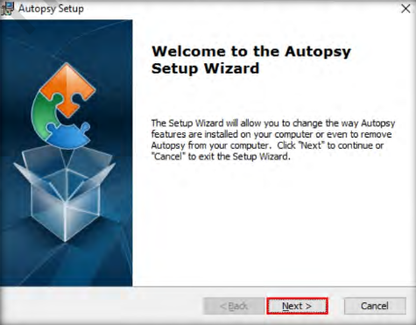

Autopsy Welcome window will appear along with Autopsy main window in the background. In the Welcome window, click New Case.

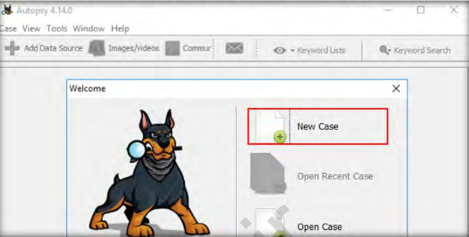

A New Case Information window opens asking you to input the Case Name and the Base Directory. The base directory is the location where the case data will get stored. The case name may be entered according to your identification purpose. In this lab, we are assigning the case name as Linux_Analysis.7.

Before specifying the base directory, we will be creating a folder on the Desktop with the name Image File Analysis and setting the path of the Base directory to this folder. Upon setting the base directory, click Next

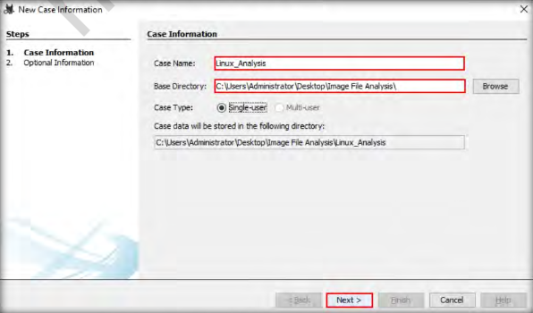

The New Case Information window now shows the Optional Information section where you can specify details such as name of the examiner and case number. For this lab, let us enter the name of the examiner as Jonathan and the case number as 1001-125. You may also fill out the other optional fields. Click Finish after entering the details for optional fields.

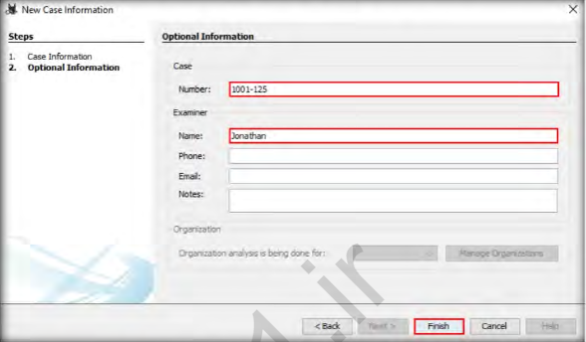

The Add Data Source window now appears displaying the section Select Type of Data Source to Add. Here,you need to select the type of data source to be provided as an input. In this lab, we will be analyzing a disk image; therefore, select the option Disk Image or VM File and click Next.

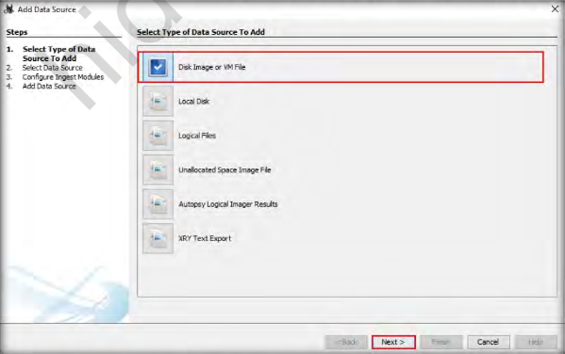

A window (named Open) will appear where you need to specify the forensic image. Navigate to C:\CHFI-Tools\Evidence Files\Forensic Images, select Linux_Evidence_001.img and click Open.

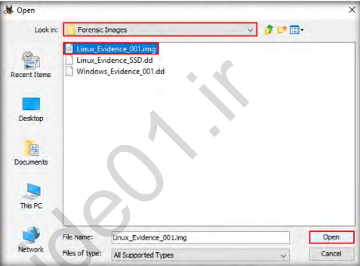

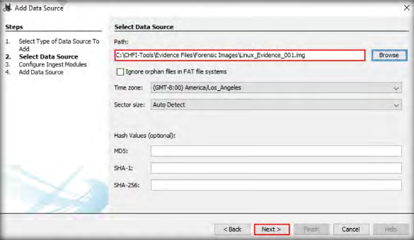

The Add Data Source window now displays the Configure Ingest Modules section, which contains lists of options that are checked. Select the options according to your requirement and click Next.

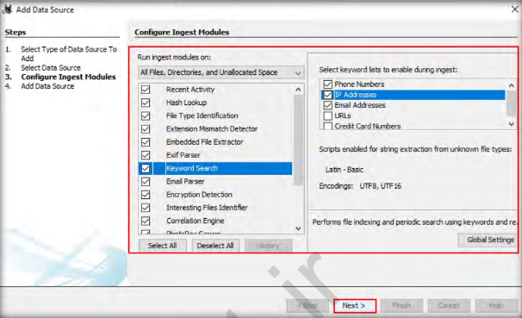

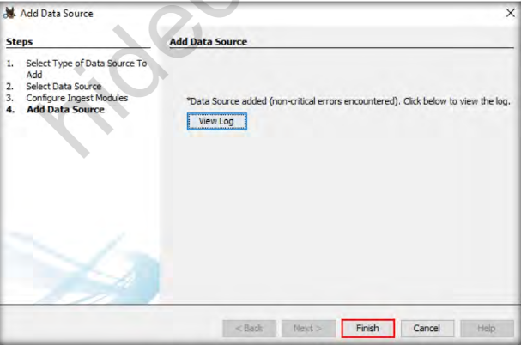

The application now displays the result in the Autopsy main window. Expand the Data Sources node in the left pane and click on the image file i.e.,Linux_Evidence_001.img. This will show the contents of the image file, as shown in the following screenshot:

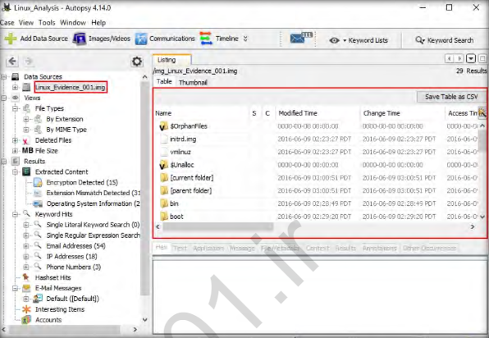

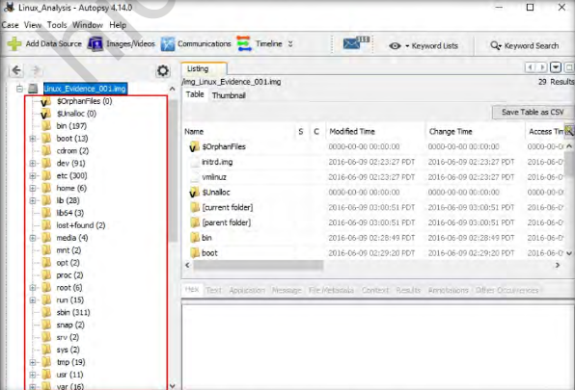

You may examine all the required files stored in the image as a part of filesystem analysis. In this lab, we are going to view the passwd file that is stored in \etc location. Therefore, select the etc folder from the left pane.

Upon selecting the folder, all the files and folders present in etc are displayed in the right pane of the window.

Scroll down the window, select the passwd file and click the Text tab.

Autopsy displays all the text (user account information) present in the passwd file, under the Strings tab,

as shown in the following screenshot:

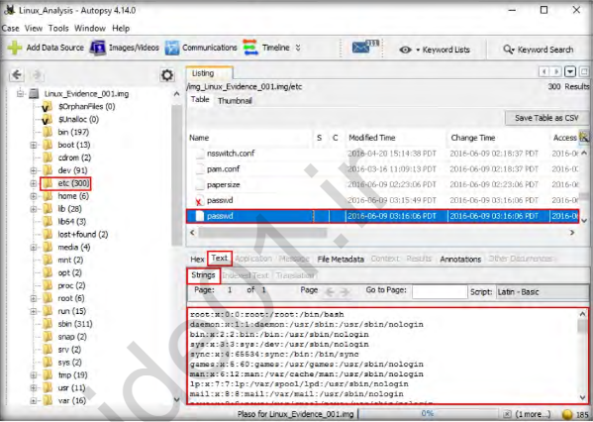

The SeatPlan.xls file appears in the right pane of the Autopsy window. Click the file.

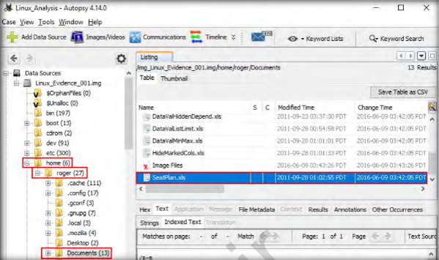

Click on File Metadata and scroll down the section to find the MD5 value for the SeatPlan.xls file.

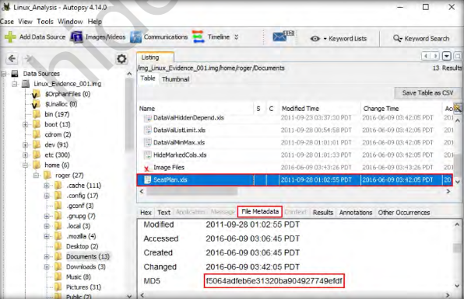

**To study fsstat**

To view partition tables associated with Windows_Evidence_002.dd, type mmls "C:\CHFI-Tools\EvidenceFiles\ForensicImages\Windows_Evidence_002.dd"and press Enter. This displays the partition layout of a volume system (partition tables) associated with the image file, as shown in the following screenshot:

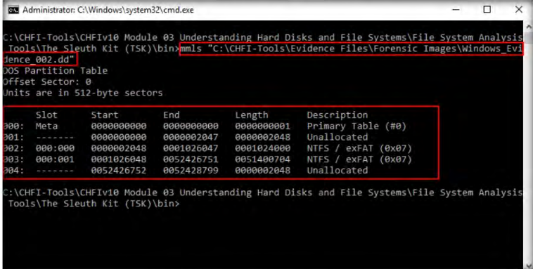

Similarly, to view the type of file system and the OS related to the image, type fsstat "C:\CHFI-Tools\Evidence Files\Forensic Images\Windows_Evidence_001.dd"and then press Enter.

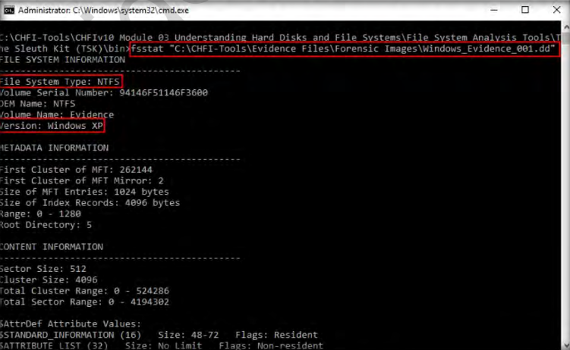

From the above screenshot, it can be observed that the file system is NTFS and the source OS is Windows XP

**To Study img_stat**

Use the img_stat command to view the details of the selected image. Type img_stat"C:\CHFI-Tools\Evidence Files\Forensic Images\Windows_Evidence_001.dd"and press Enter to view the details.

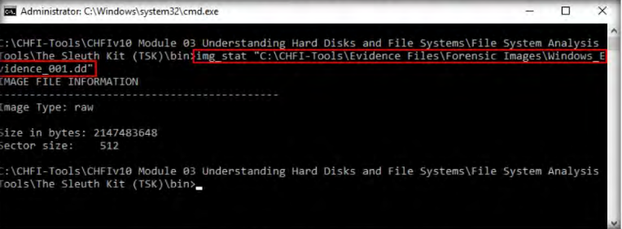

**To Study istat**

Use the istat tool in The Sleuth Kit to view the details of metadata structure. To display an overview of the MFT file, type istat -f ntfs "C:\CHFI-Tools\Evidence Files\Forensic Images\Windows_Evidence_001.dd" 0 and press Enter to view the details.

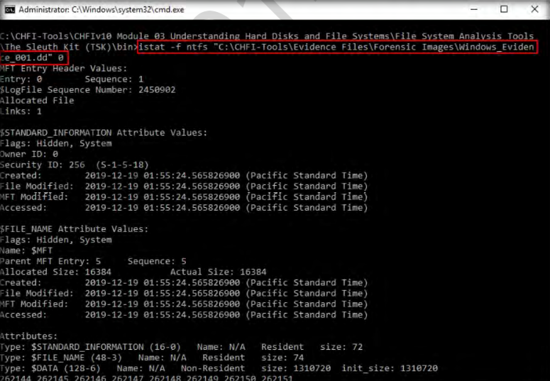

To display the MFTMirr File Overview, type istat -f ntfs "C:\CHFI-Tools\Evidence Files\Forensic Images\Windows_Evidence_001.dd" 1 and press Enter.

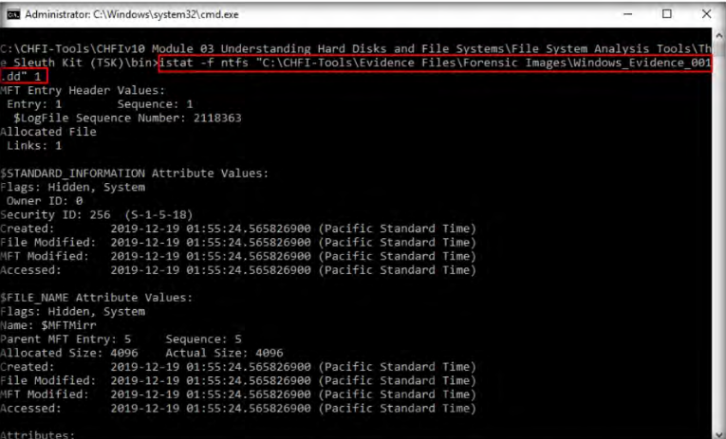

The layout of the MFT is determined by processing entry 0 in the MFT.MFT entry 1 is for the MFTMirr file, which has a non-residentattribute that contains a backup copy of the first MFT entry. The Boot file system metadata file is in MFT entry 7 and contains the boot sector of the file system. The MFT entry for the AttrDef filesystem metadata file is 4. It defines the names and type identifiers for each type of attribute. NTFS keeps track of the damaged clusters by allocating them to a$DATA attribute of the BadClus file system metadata file. The MFT entry is 8.

**To Study fls**

Use the fls command-line tool of TSK to list the files and directory names. Type fls -f ntfs "C:\CHFI-Tools\EvidenceFiles\ForensicImages\Windows_Evidence_001.dd"and then press Enter.

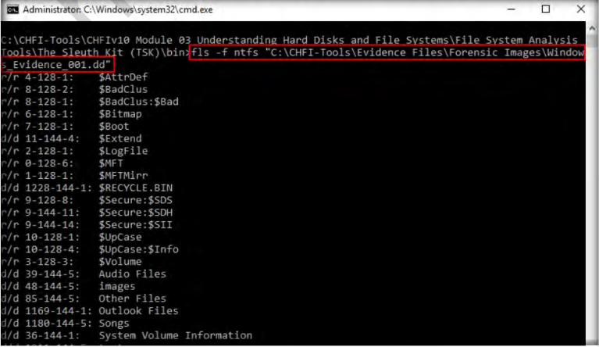

**PRACTICAL NO.02**

1. **Explore Windows forensic tools (OSForensics)**

Navigate to C:\CHFI-Tools\CHFIv10Module 06 Windows Forensics\Windows Forensics Tools\OS Forensics, double-clickosf.exe to launch the steup. In the final step of installation, check the Launch OSForensics option and click Finish. OSForensics GUI appears, along with PassMark OSForensics pop-up. In the pop-up, click Continue Using Trial Version. Our first task is to create a case using this tool. Click the Create Case icon in the tool’s main window to create a new case.

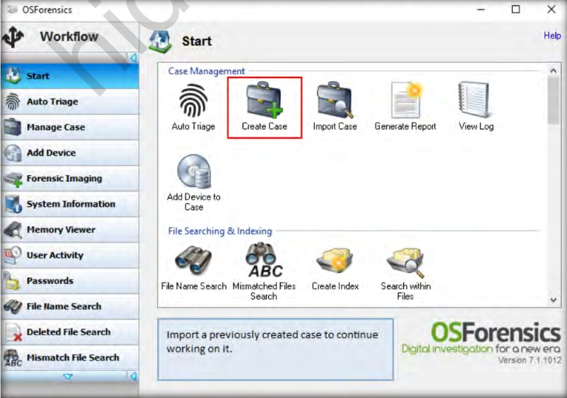

A New Case window appears; fill out the required fields in the window. Ensure that you select the radio button for the Live Acquisition of Current Machine option in the Acquisition Type category. You may choose to save the new case folder either in Default or Custom locations. Click OK

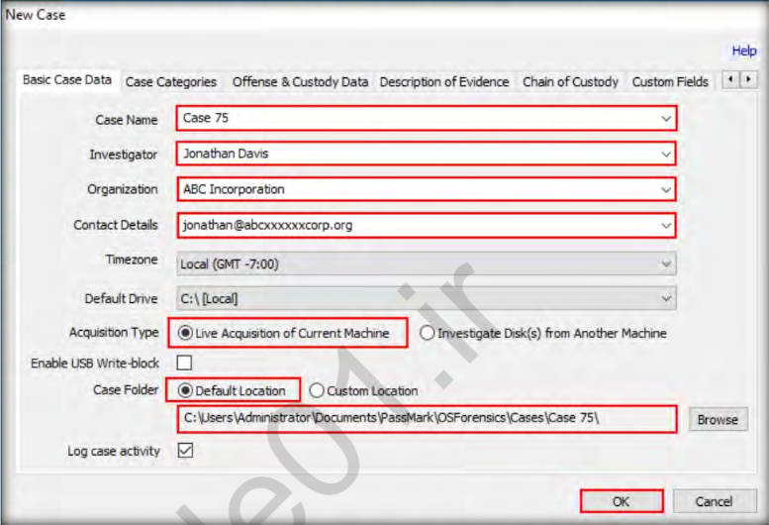

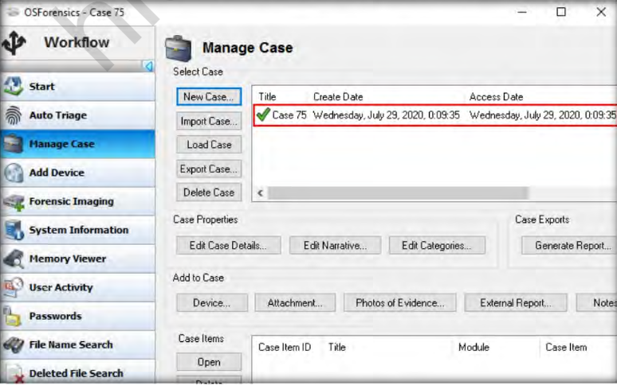

The OSForensics tool can help investigators in searching and locating files on a system. To start searching for files, click File Name Search in the left pane of the window.

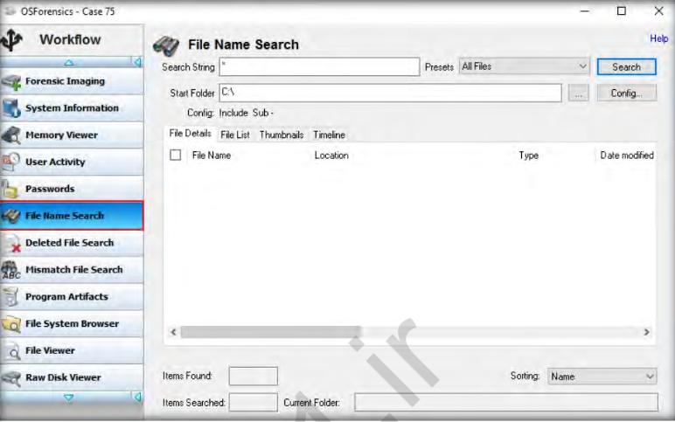

In the Start Folder field, specify the path to search for image files by clicking the ellipsis button and choosing the location (here, we are specifying the location C:\CHFI-Tools\EvidenceFiles\Image Files to search for images in it). Then, click the Search button.

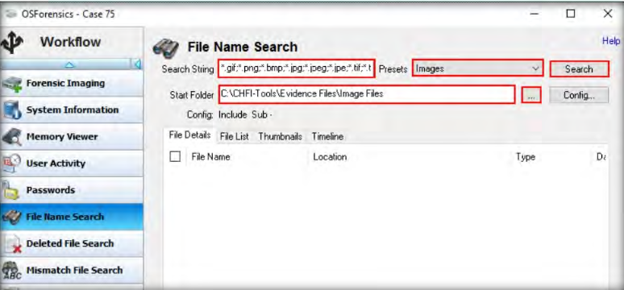

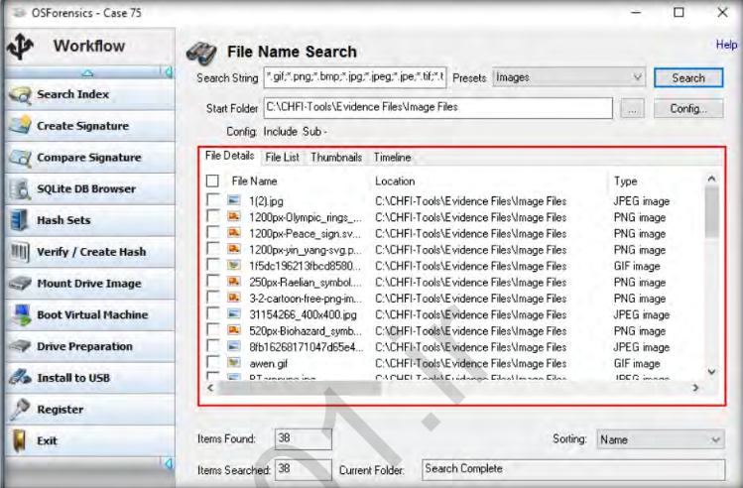

Alternatively, if you wish to search only for a single image on the entire system, select Images from the Pre-sets drop-down menu, enter the name of the desired image file in the Search String field, and then click Search, as shown in the screenshot below. Here, we are searching for the JPEG image file named Kitty.

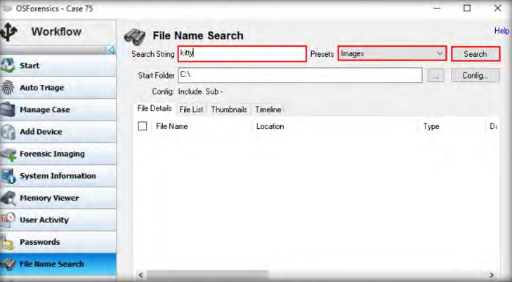

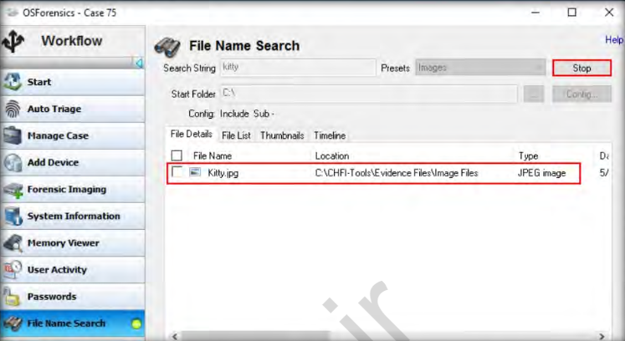

The Create Index section appears in the right pane. In this section, select the Use Pre-defined File Types option for creating the index and check the required options listed under it for selecting the file types that you wish to index (here, we have selected the Images option). Then, click Next.

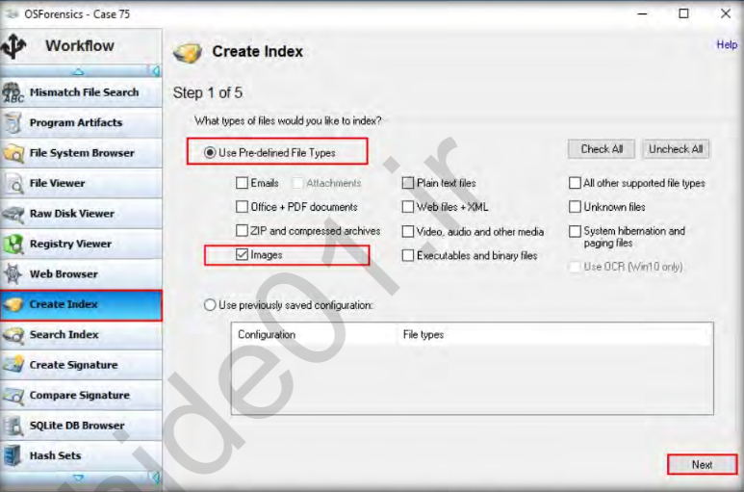

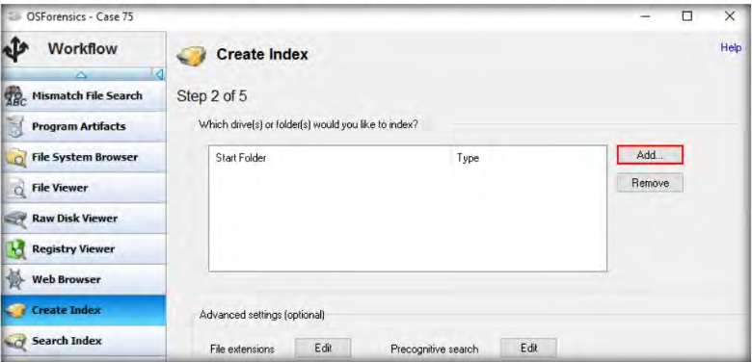 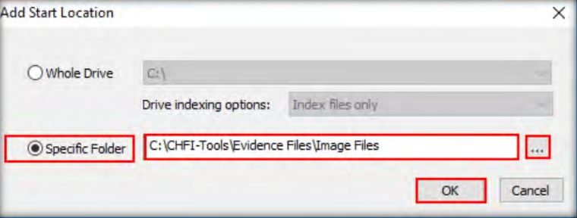

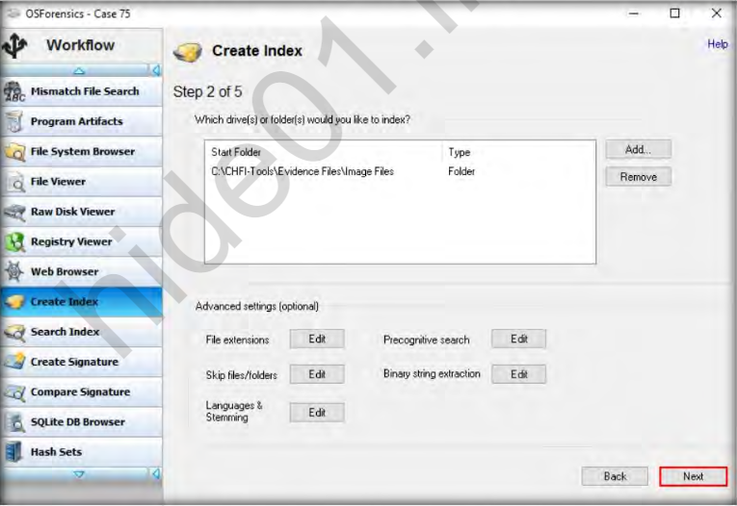

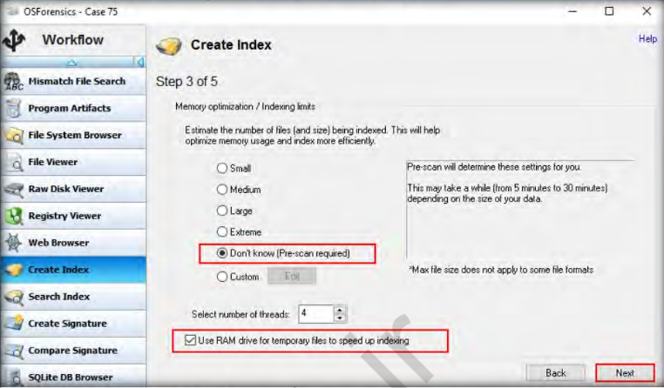

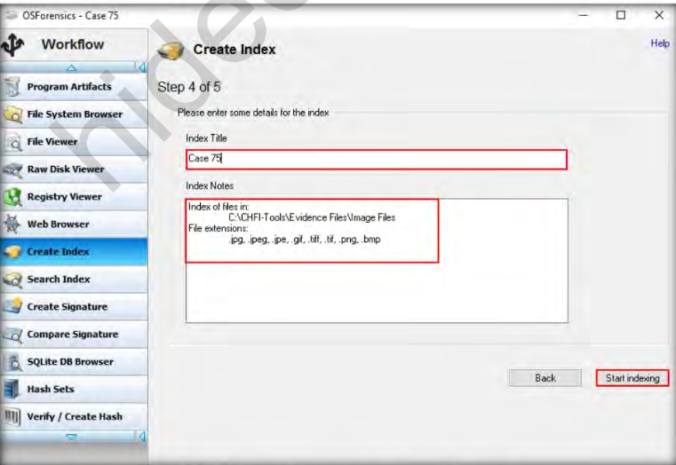

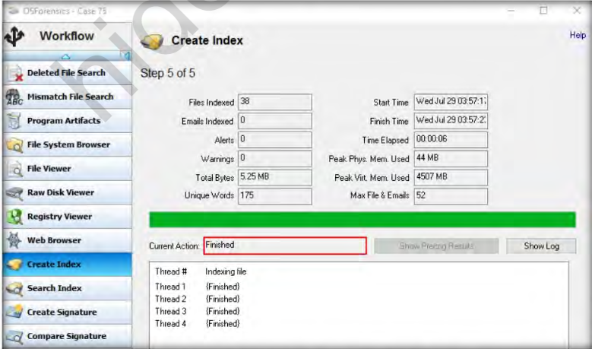

We will now search the indexed files. To search for the indexed files, select Search Index from the left pane of the tool window. The Search Index section now appears in the tool window. The index field at the top displays the name of the case we created (i.e., Case 75). Click Search. The tool will load the image files that you have indexed under the Images tab.

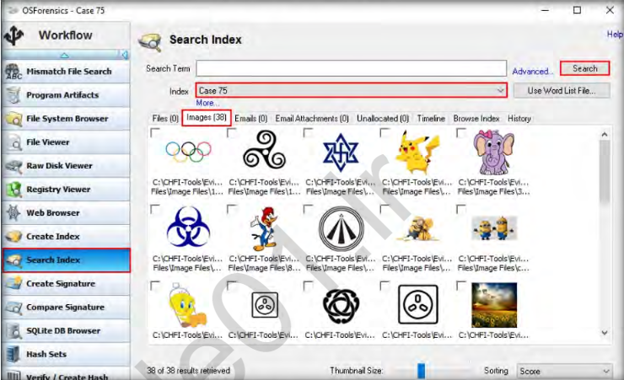

Click User Activity in the left pane to scan for evidence such as browsed websites, USB drives, recent downloads and wireless networks.

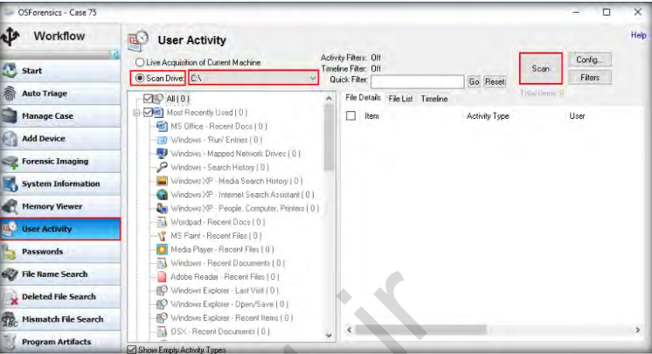

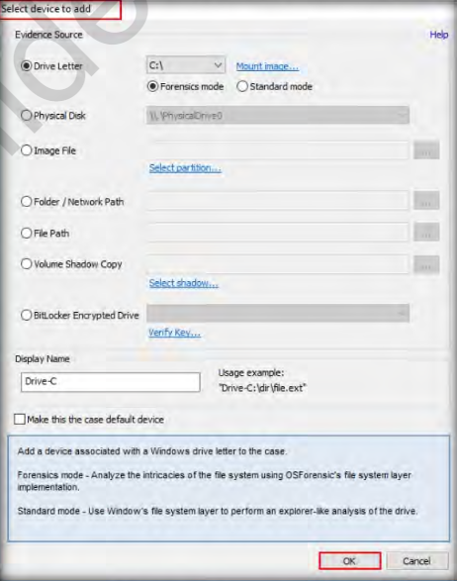

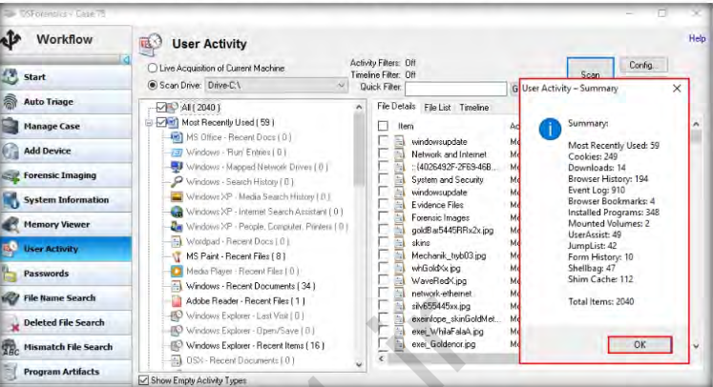 If you wish to save any of the above user-activity information on your system, such as Browser History, then scroll down the items list in the left pane below the Scan Drive option and expand the Browser History node. Select the browser for which you wish to retrieve the history (Here, we are selecting Chrome). The browser history pertaining to this browser will be displayed in the right pane of the tool window.

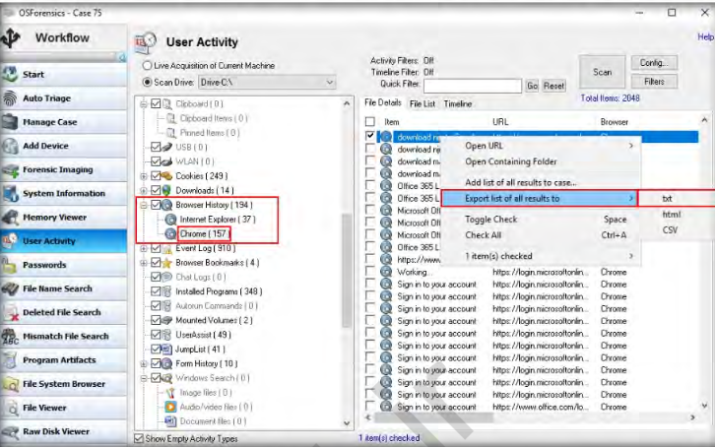

An Export List to. Window will appear. Navigate to C:\Users\Administrator\Documents\PassMark\OSForensics\Cases\Case 75, name the file (here, we are naming it as Browsing History), and click Save to export the browsing history.

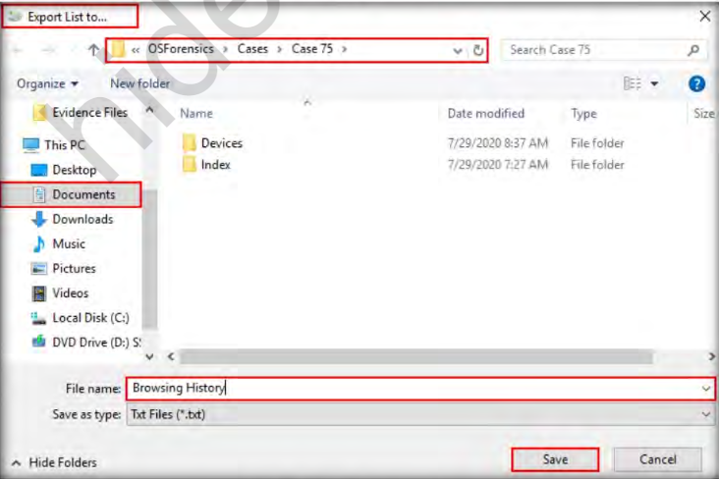

To recover deleted files from the file system, click Deleted File Search in the left pane, select a disk on which you wish to perform the deleted file search from the Disk drop-down menu, and click the search button.

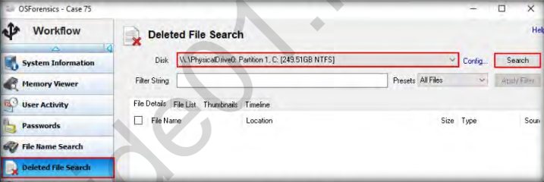

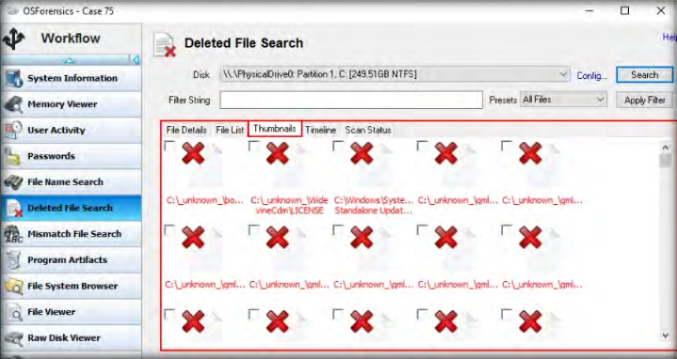

To locate files having contents that do not match the file extensions, click Mismatch File Search in the left pane of the tool window. The tool will display the Mismatch File Search section in the right pane, as shown in the screenshot:

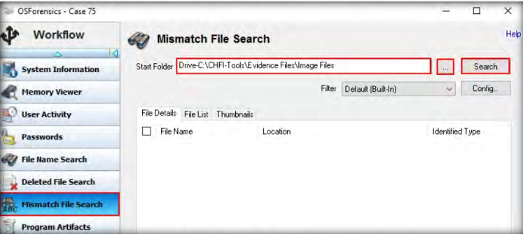

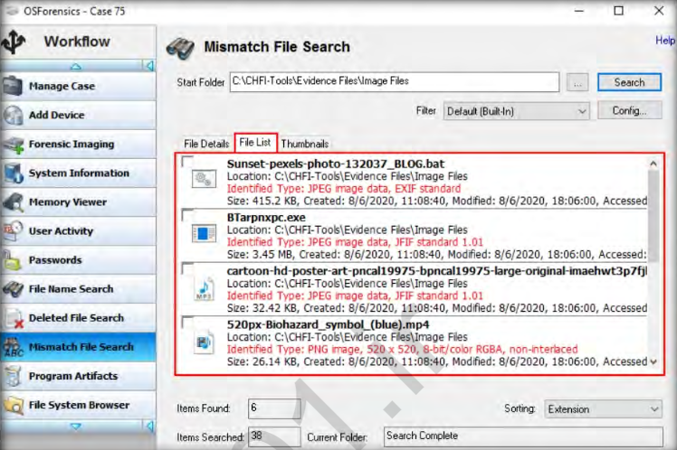

To view the processes running on the system, click Memory Viewer

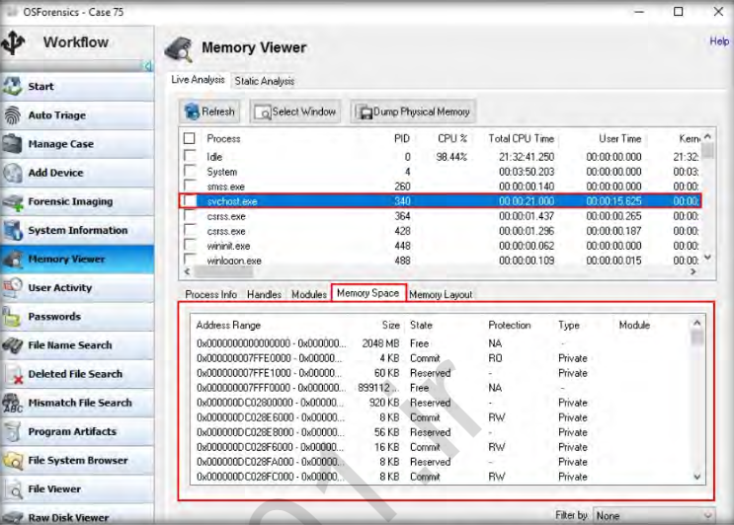

To retrieve detailed information about the core components of the system, click System Information. The tool will display the System Information section.

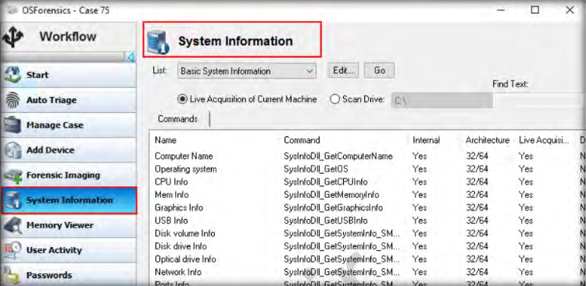

In this manner, you can perform investigation on a system or the folders and partitions within the system to gather data of interest to the forensic investigation.

**PRACTICAL NO .03**

**Using Forensic Toolkit (FTK) &Writing report usingFTK (AccessData FTK)**

**Aim: Using Windows Forensics Tools.**

Step 1: Start Forensic Toolkit.

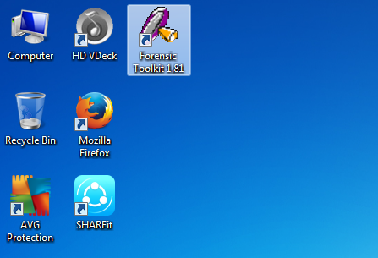

Step 2: Here, prompted with a warning dialog box, click on OK to continue.

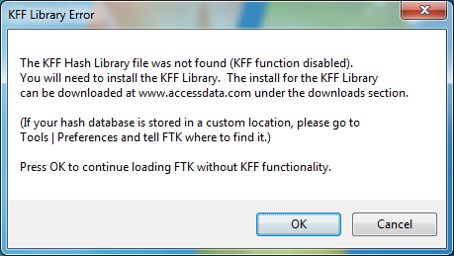

Step 3: click on OK button.

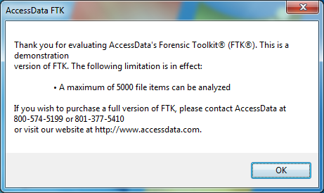

Step 4: Now select Start New Case option and click on ok.

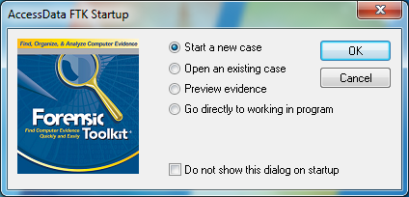

Step 5: Enter the detail for a New case.

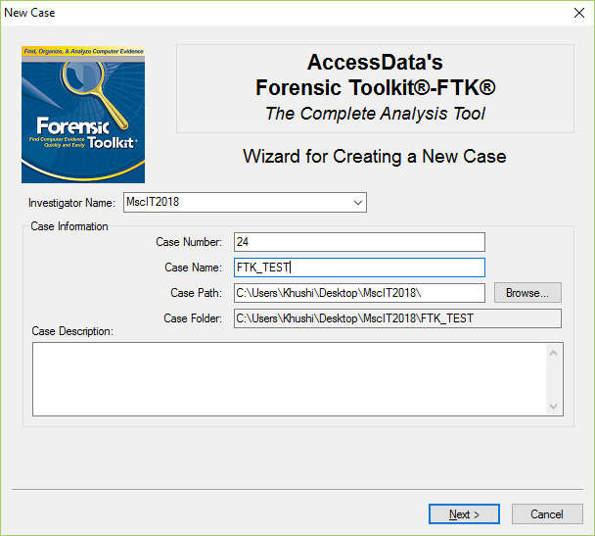

Step 6: Fill the information in Forensic Examiner Information dialog box.

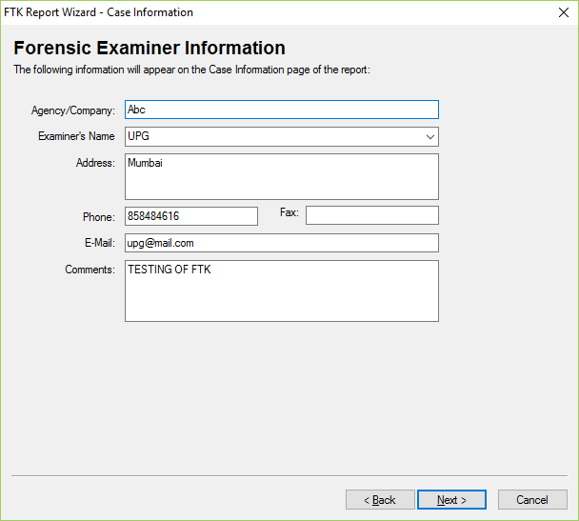

Step 7: leave the default settings and click on next.

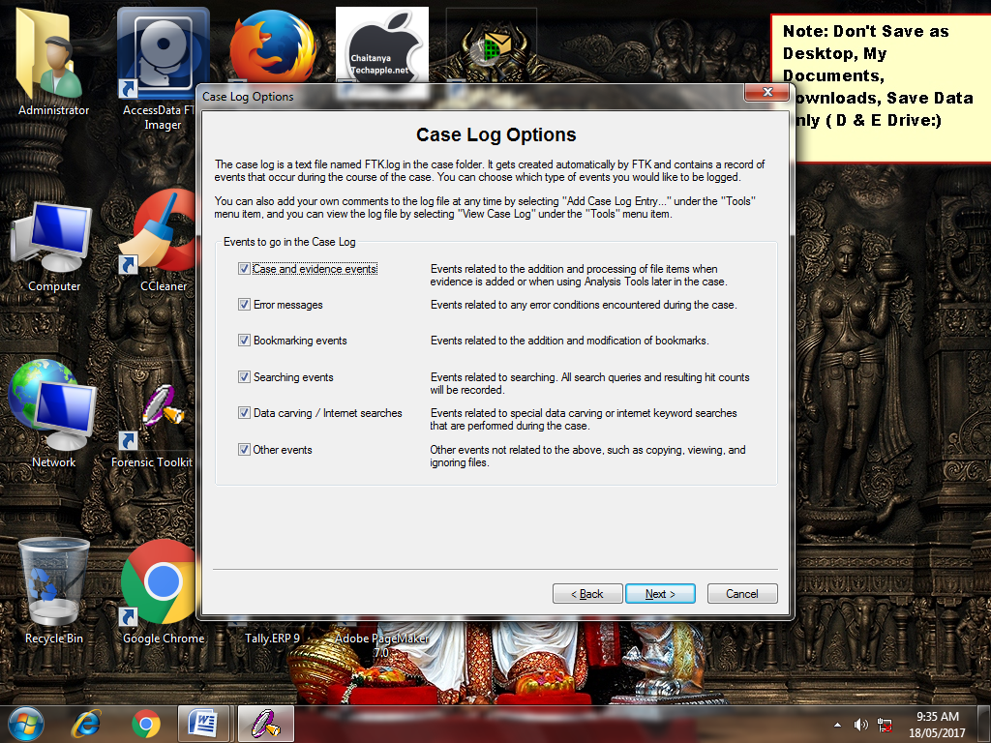

Step 8: Now again leave the default settings and click on next.

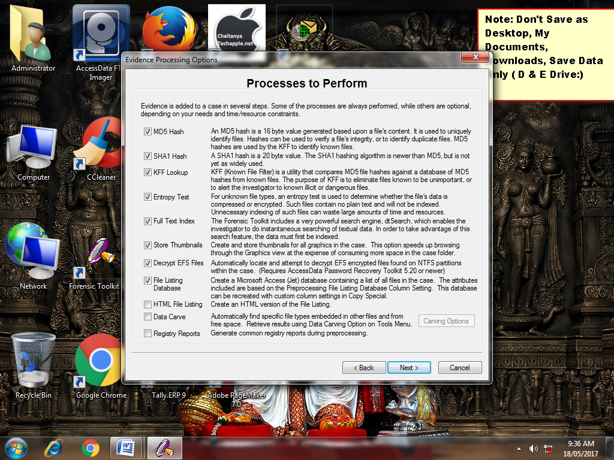

Step 9: In the Refine Case-Default, click the Include All items button and then click Next.

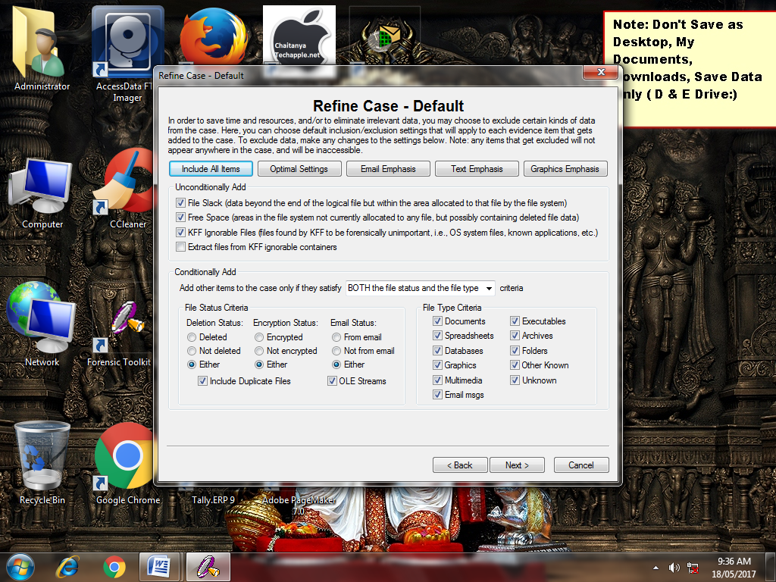

Step 10: In Refine Index-Default, accept the default settings and click Next.

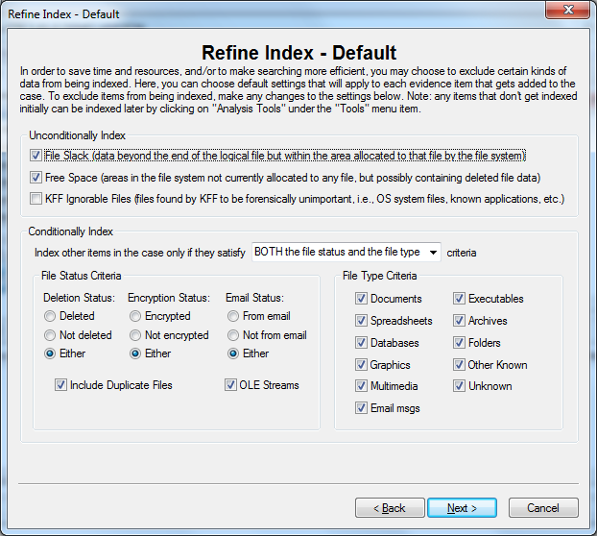

Step 11: Now here Click on add Evidence button.

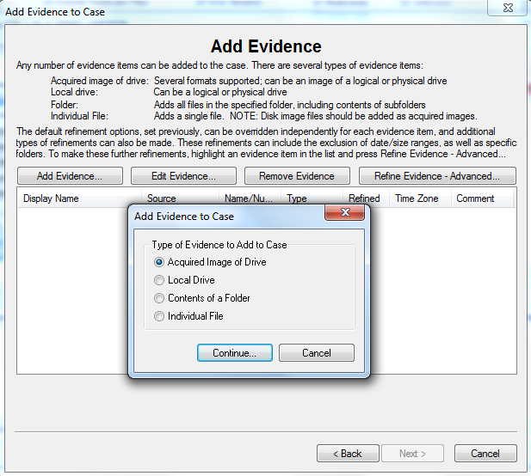

Step 12: Enter Evidence Information and click on OK button.

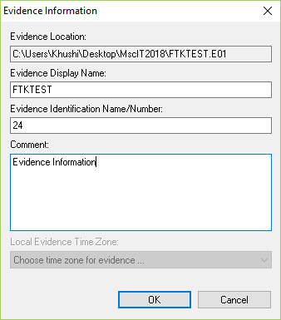

Step 13: Now click on Next.

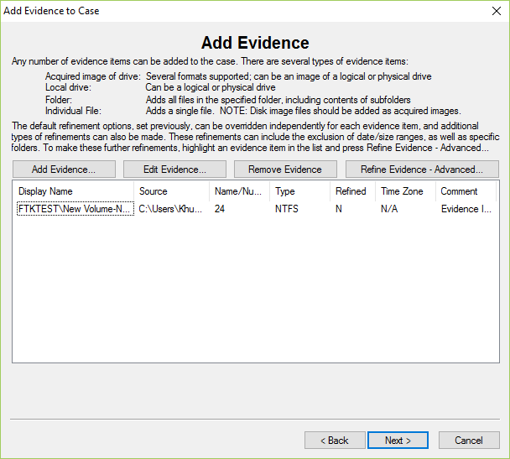

Step 14: Click on Finish to initiate the analysis.

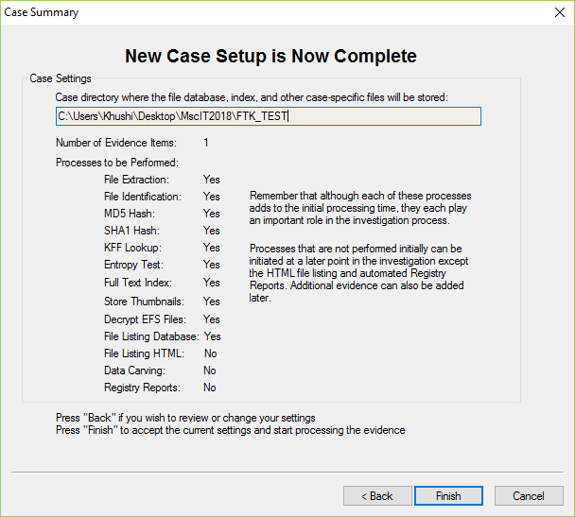

Step 15: Now Processing Will Start........

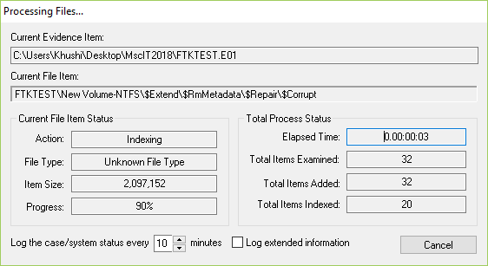

Step 16: when FTK finishes the processing part, the FTK window opens to the Overview tab.

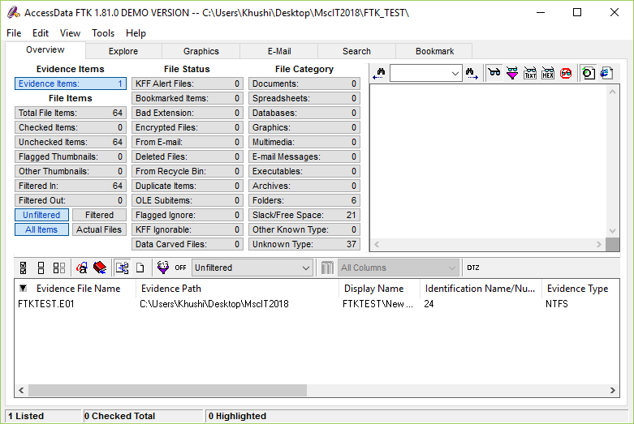

Step 17: Select Deleted Files option to explore the evidence items.

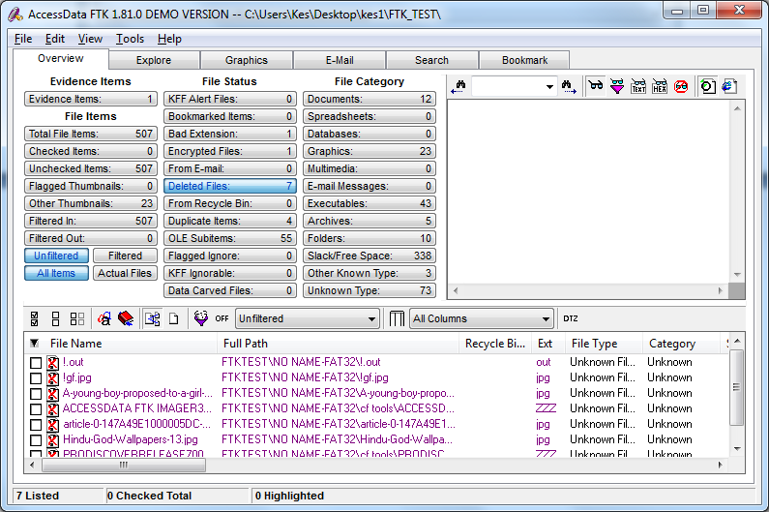

Step 18: Select Encrypted Files to view.

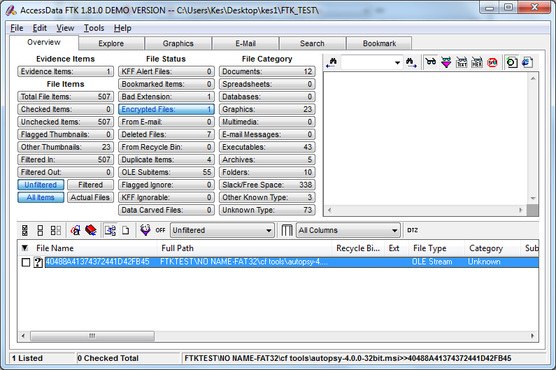

From the menu, select **Report**, and then **Generate Report** or click the button on the toolbar.

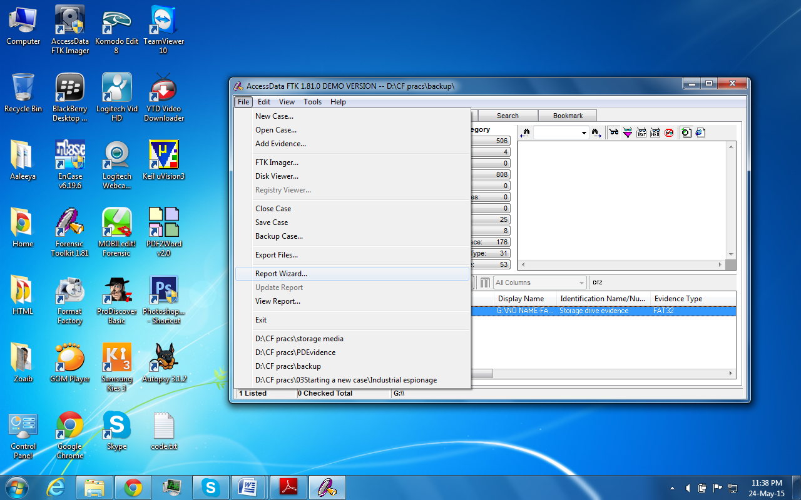

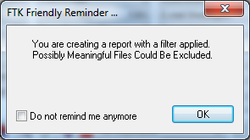

The Case Information dialog appears, enter the Case information and The Bookmarks-A & B dialog appears select what you want to include in report click next.

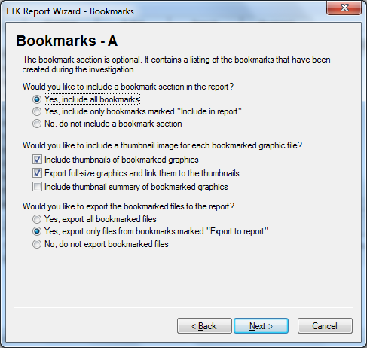

List File Properties dialog appear, include the list you want in Report and click next and Finish.

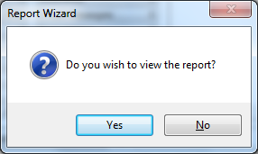

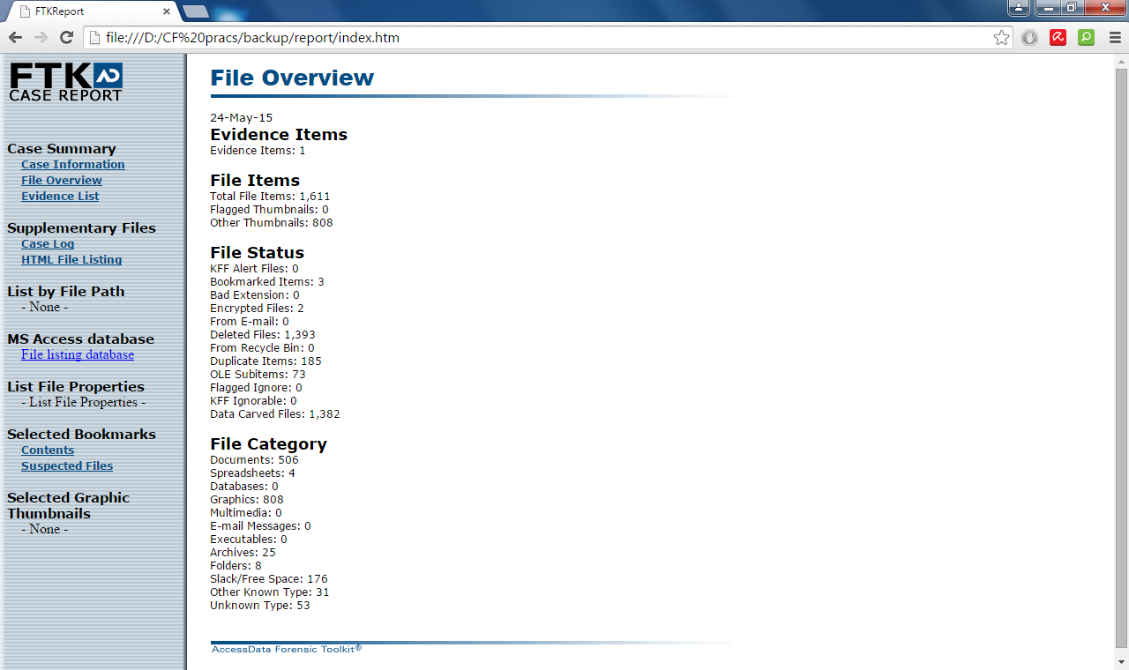

**PRACTICAL NO: 09**

1. **Performing Password Cracking [Cain & Abel]**

Step 1: Install and open cain and abel.

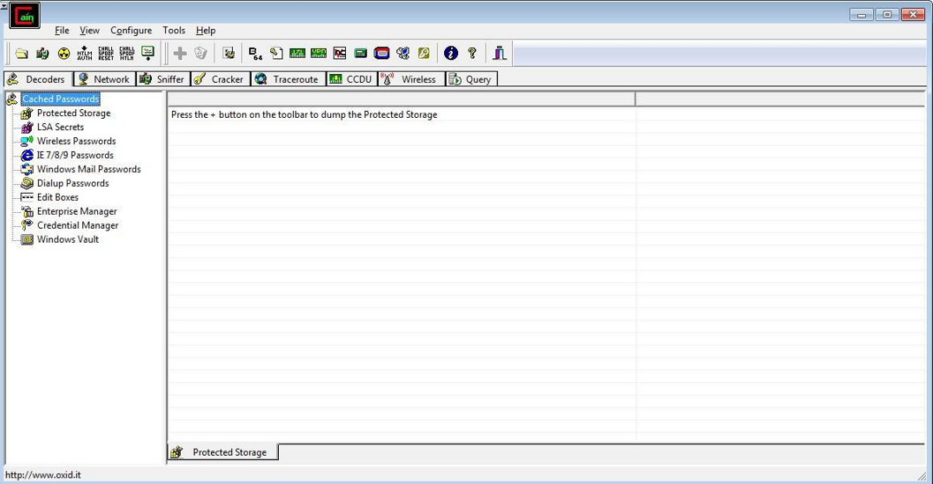

Step 2: Select sniffer on the top.

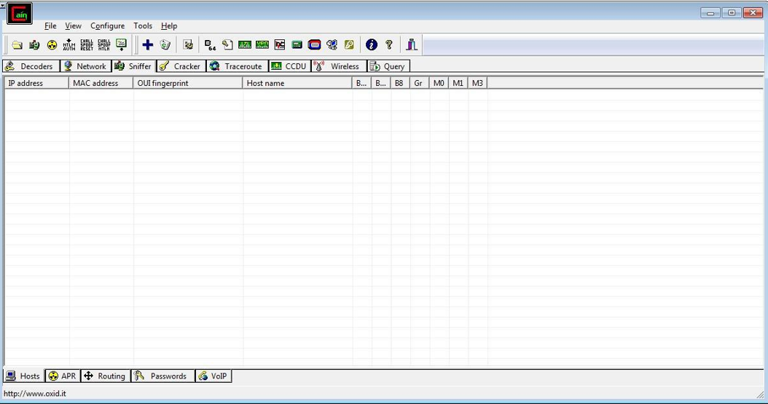

|  |  |
| --- | --- |
| Step 3: Next to folder icon click on icon name start/stop sniffer. | Select device and click on ok. |

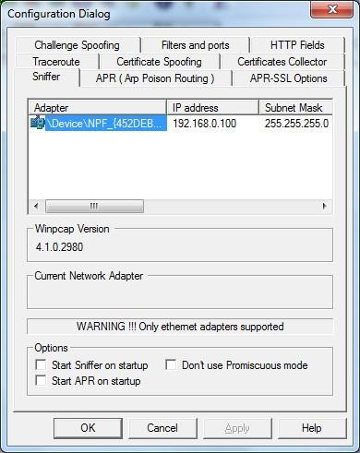

Step 4: Click on “+” icon on the top. Click on ok.

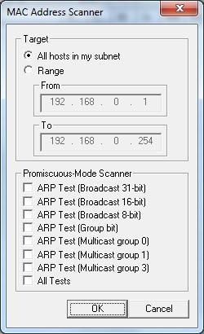

Step 5: Shows the Connected host.

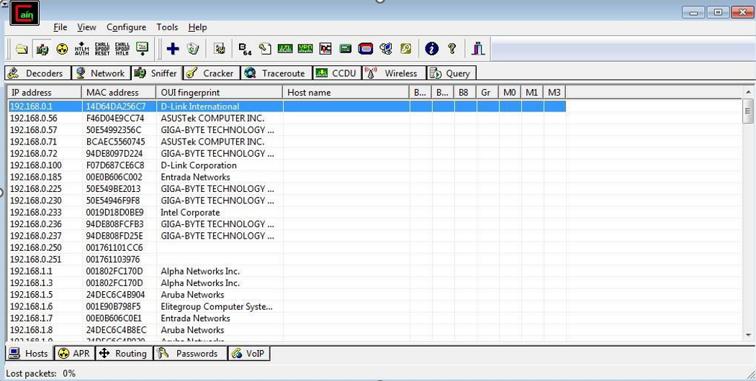

Step 6: Select Arp at bottom.

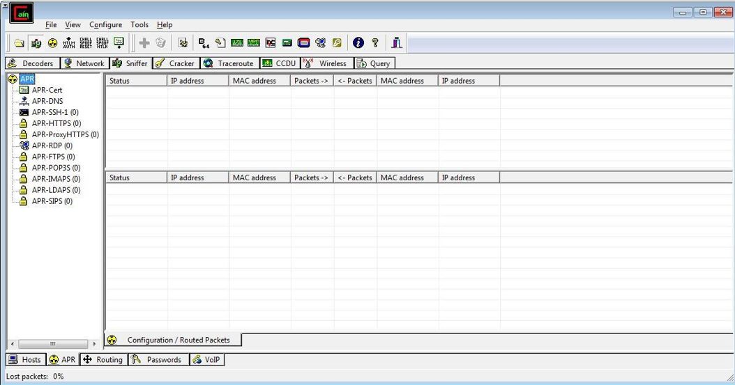

Step 7: Click on “+” icon at the top.

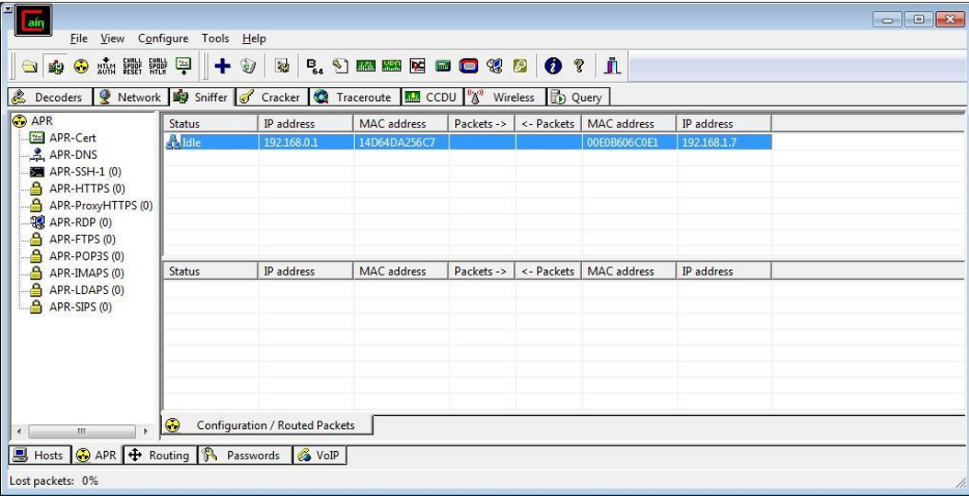

Step 8: Click on start/stop ARP icon on top.

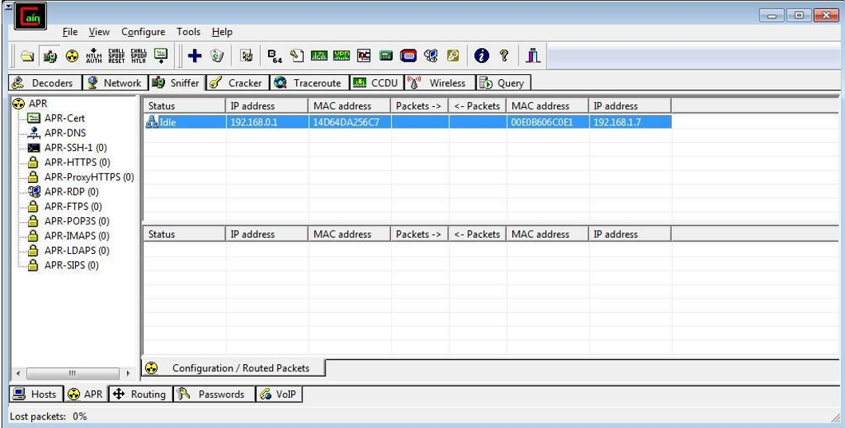

Step 9: Poisoning the source.

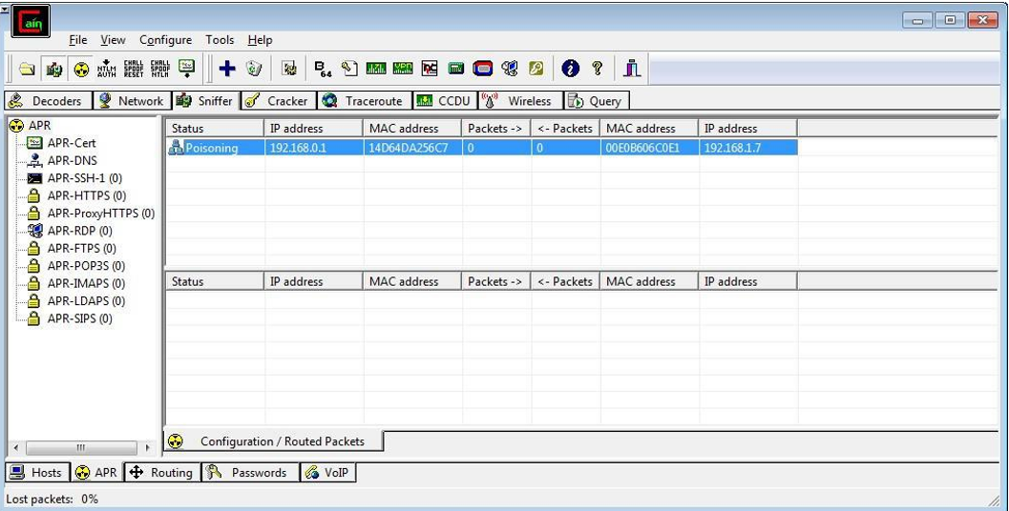

Step 10: Go to any website on source ip address.

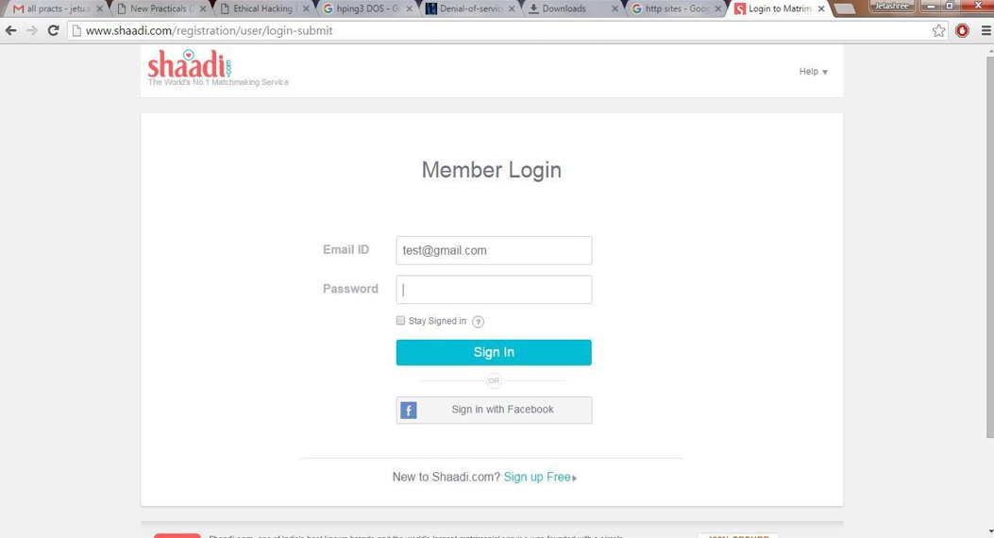

Step 11: Go to password option in the cain & abel and see the visited site password

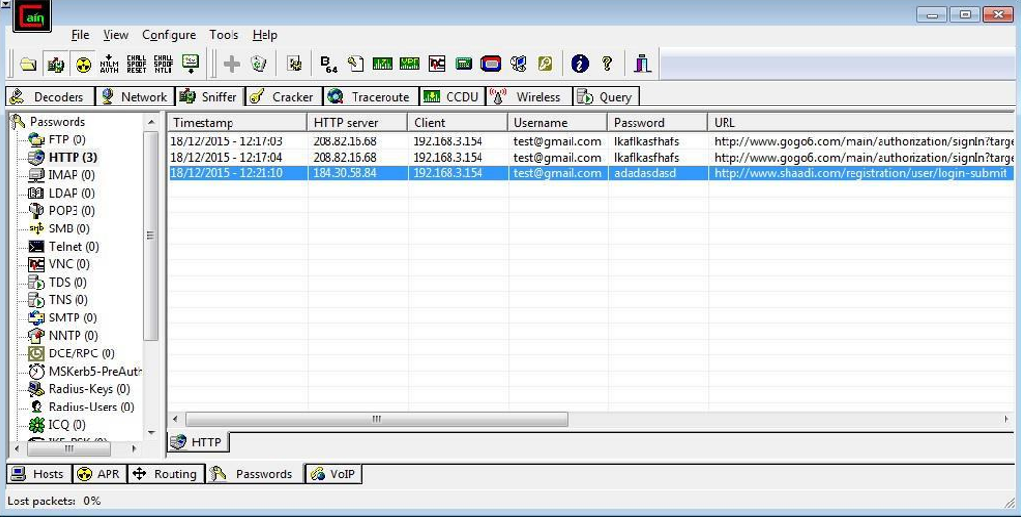

**PRACTICAL NO:10**

1. **Scan Registry using RegScanner**

Step 1) Download and Install RegScanner

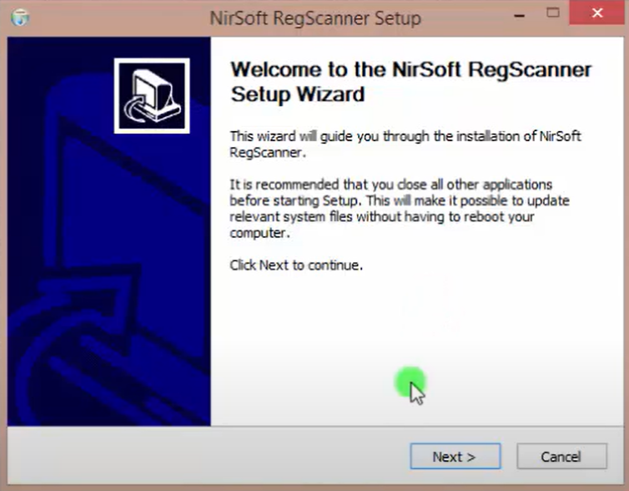

Step 2) Quickly scan your Registry and Search for the specific values with RegScanner

You can select to scan the base keys and the string types. Enter the search string and start the scan

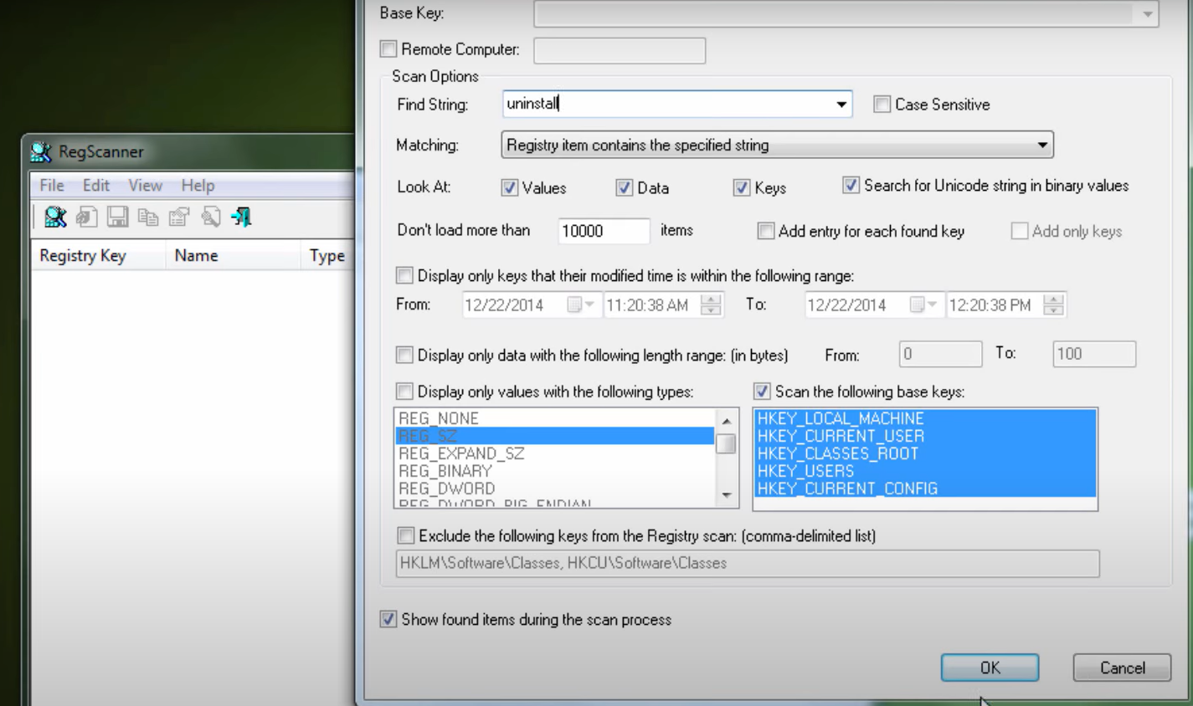

Step 3) Check the Scan Result

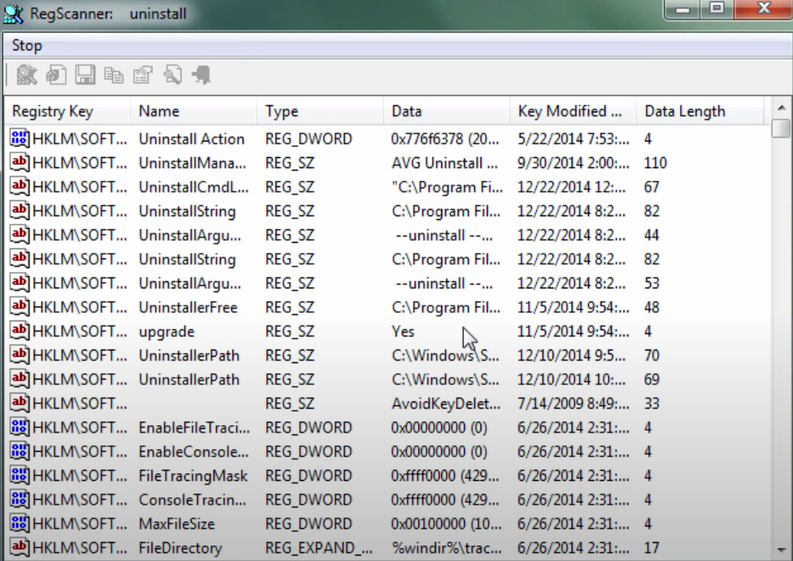

Step 4) You can save, copy or export the selected items, Export Reg values as REG or

HTML files, and more

